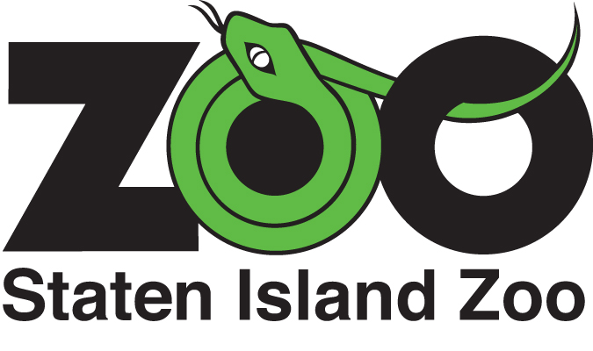
Docent and Jr. Docent
Application 2018
***Please note: Applications are due: Nov. 1, 2017***
Name: |  |  | Date:
Address:
City: |  | State: | Zip:
Phone: | E-mail Address:
Please check which docent program  you are interested in: | Docent Jr. Docent (14-18 years)

Closest relative/Emergency Contact:
Name:
Home #: | Work #: | Cell #:
E-mail address:
Why do you want to be a docent?

Please share your experience with animals:

Please share your experience with teaching:

Do you have any allergies?

When are you available to be at the Zoo?
Sunday Monday Tuesday Wednesday Thursday Friday Saturday

Please provide one reference from someone, not related to you, familiar with your work ethic.
Name:
Address:
City: |  | State: | Zip:
Phone: | E-mail address:

PLEASE READ THE ADDITIONAL VOLUNTEER GUIDELINES ACCOMPANYING THIS APPLICATION.
If accepted into the program, you will also be required to read the Zoo’s Volunteer Handbook.

Please sign in the appropriate field, indicating that you have read & understand the Volunteer Guidelines.
Docent (print and sign):
Interviewer/Date:
Volunteer Coordinator:
Zoo Supervisor:
Date of first assignment:

Please email or mail application to:
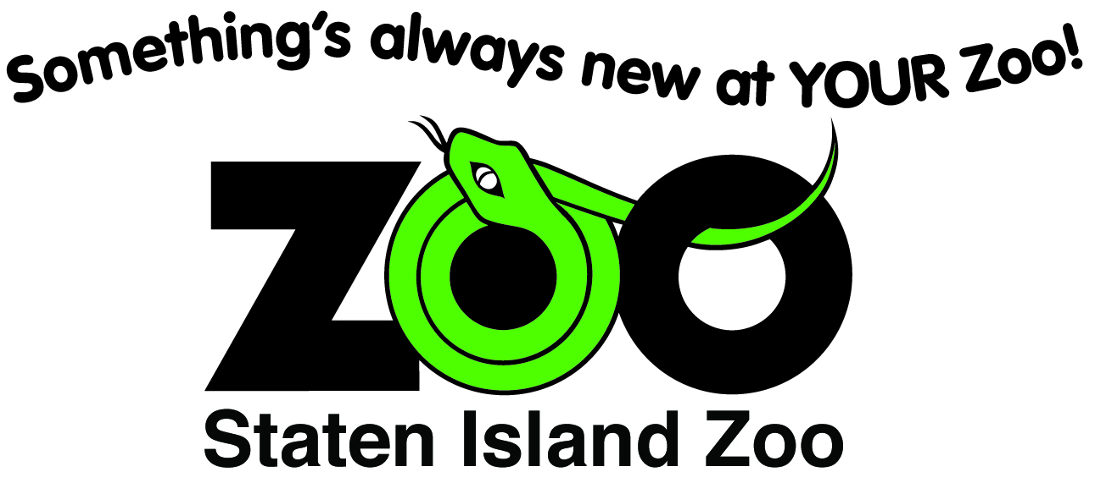 Megan Molok, Volunteer Coordinator
Staten Island Zoo
614 Broadway Fax: 718-442-8492
Staten Island, NY 10310 E-mail: Education@StatenIslandZoo.org

All volunteers must be capable of working both independently and as part of a team.

Staten Island Zoo volunteers are subject to a thorough background check. The Staten Island Zoo reserves the right to alter the volunteer program or its contents in any way without prior notice. The Staten Island Zoo volunteer positions may be terminated at any time per the discretion of the Zoo and without previous notice.

The Staten Island Zoo is committed to the principle of equal educational opportunities without the discrimination of race, color, sex, national origin, age, religion, or presence of a legally protected disability or any other legally protected status.

Unfortunately, because of the high volume of applications we receive, we aren’t able to give status updates. Please wait for the Zoo to contact you regarding your potential acceptance into the program.

Thank you for your interest in the Staten Island Zoo’s Volunteer Program!

NOTE: All candidates will be notified by mail, e-mail, or phone of application results.
All Volunteers must provide record of a negative TB Test before the start of the program.

Docents and Jr. Docent Requirements
Must have proof they are negative TB Test given to Zoo yearly
Must attend 10 week Course starting in February
- Application and interview by the Docent/Volunteer Coordinator for acceptance into the program. Prospective docents must present 1 reference for acceptance.
- Attendance to no less than 8 classes (work missed in any class must be made up).
- Each Docent must full participate in class discussions, complete all homework, pop quizzes and take-home exams.
- Become certified in a zoo wing or specialized area plus 2 animals from our education collection.

Must participate in Spooktacular (Dates TBA). If you cannot be available those days, please help with preparation.

Rules Specific to Docents
- All Docents must be at least 18 years old.
- Each Docent must attend at least 5 out of 11 annual Docent Meetings held once a month and at least 1 out of the 3 annual “What’s Happening Meeting”.
- Each Docent must attend one Zoo science/conservation lecture annually.

Must participate in Spooktacular (Dates TBA). If you cannot be available those days, please help with preparation.

